General Nutrition Guidelines:
Plate Breakdown
- Each meal should consist of the following:
  - Protein source
  - Carbohydrate source
  - Fat source
  - Vegetable (1-2 cups)
- Protein intake per day approximately 2.0 grams per kilogram of bodyweight
- Carbohydrate intake per day approximately 8-10grams per kilogram of bodyweight
- Fat intake per day approximately 1.5 grams per kilogram of bodyweight

Meal Breakdown
- Shoot for 4-5 feedings (meals and snacks) per day
- 25-35 grams of protein per meal
- 50-75 grams of carbohydrate per meal
  - 30 grams of carbohydrate during workouts/practices/game
- 15-20 grams fat per meal

Macro Sources
Protein:
- Fish
- Chicken Breast
- Turkey Breast
- Meat (90% lean or leaner)
- Eggs

Carbohydrate:
- Whole Grain Bread
- Potato
- Sweet Potato
- Oatmeal
- Whole Wheat Pasta
- Rice

Workout Carbs:
    - Gatorade/Powerade
    - Coconut Water
    - Carb Mix
    - Juice

Fat:
- Nuts
- Avocado
- Olive Oil
- Natural Nut Butters
- Canola Oil

Snacks:
- Beef Jerky
- PB and J
- Banana and Peanut Butter
- Greek Yogurt
- Protein Shake Plus a Healthy Carb

When planning snacks I like to envision a healthy protein source and a healthy carb source! There are tons of options…choose foods you enjoy eating that fall into the previously mentioned categories.

Hydration:
- 0.5-1 ounce of water per pound of bodyweight
- Drink water as soon as you wake up in the morning. Get ahead early!
- Outside of intense training/workouts (Gatorade/powerade), stick to water.

Tips/Tricks:
- Make breakfast a priority
  - If trying to gain weight try to have 800-1000 calories consumed before 10am
- Prepare for your day of meals/snacks (either the night before or that morning)
  - Pack snacks to fill in the holes between meals
- If caught unprepared, a poor food choice (OCCASIONALLY!) is better than not eating or skipping a meal. DO NOT MAKE IT A HABIT OF EATING FAST FOOD!
- If you are doing weigh-ins, do them in the morning right after you wake up. USE THE SAME SCALE!

(1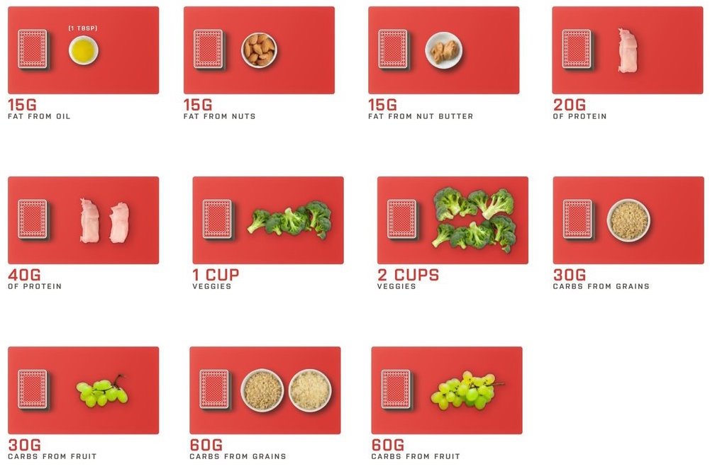 TBSP)

